# MAT 243 Project One Summary Report

Jason Wood

[Jason.wood3@snhu.edu](mailto:Jason.wood3@snhu.edu)

07-19-2025

Southern New Hampshire University

## Introduction: Problem Statement

In this project, we are conducting a comparative analysis of two NBA teams to better understand their scoring patterns and relative performance using historical data; obtained from Kaggle data competitions. Specifically, the project aims to investigate points scored and relative skills assessment (ELO) of the Boston Celtics and the Chicago Bulls; between 2013 – 2015 for the Celtics and 1996 – 1998 for the Chicago Bulls. The dataset used for this analysis includes regular season game data for all NBA teams over the span of multiple years and contains features such as; team names, years, points scored, ELO scores, etc. Data was grouped and filtered into two subsets for the Celtics for the years 2013 - 2015 and the Bulls for the years 1996 – 1998. To analyze the data; histograms and KDE plots were used to examine the score distributions and compare performance through visual metrics. Descriptive statistics; mean, median, variance, and standard deviation; are calculated to summarize team performance; with inferential statistics being employed to calculate confidence intervals and probability modeling through normal distribution of data.

## Introduction: Your Team and the Assigned Team

Table 1. Information on the Teams

|  | **Name of Team** | **Assigned Years** |
| --- | --- | --- |
| 1. Yours | Celtics | 2013 - 2015 |
| 2. Assigned | Bulls | 1996 - 1998 |

## Data Visualization: Points Scored by Your Team

Data visualization plays a pivotal role in statistical analysis through visually showcasing the data structure, spread, and skewness of the data being explored. Helping to identify central patterns and anomalies that are difficult to discern from raw data alone; outliers, trends, etc. for the Celtics, a histogram of points scored between 2013 – 2015 was chosen for the provided clarity in showing the frequency of scores. This plot was preferred over the KDE plot as it better showcases the shape of the distribution of the data.

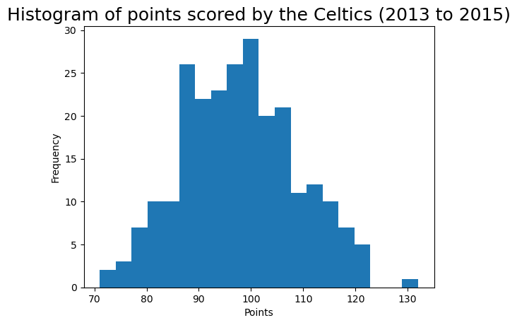

The histogram indicates that the Celtics’ scoring distribution was approximately normal, centered around a mean value typical for NBA teams during that era. There is minimal skew suggesting relatively consistent offensive output across games; with a few notable outliers for the higher ed of the scoring range.

## Data Visualization: Points Scored by the Assigned Team

To analyze the assigned team, the Chicago Bulls scoring patterns during the 1996 – 1998 seasons were visualized using a KDE plot. This plot was selected over the histogram plot due to its smoother representation of the distribution; showcasing some subtle features of the data.

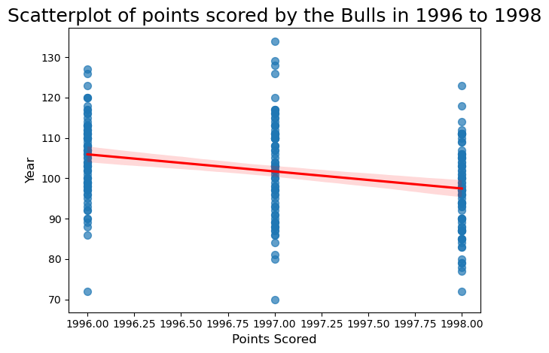

The KDE plot shows that the Bulls’ scoring distribution was slightly skewed to the right, most games falling within a consistent scoring range with a few outliers containing higher total points. This right skew suggests that while the Bulls often scored moderately, they occasionally had high-scoring performances; pulling the mean higher than the median.

## Data Visualization: Comparing the Two Teams

To directly compare the Celtics and the Bulls; a side-by-side comparison was conducted through the overlay of distributions within the histogram. This visualization is crucial for identifying differences in team performance, as it visually displays were each team’s scoring ranges overlap or differ.

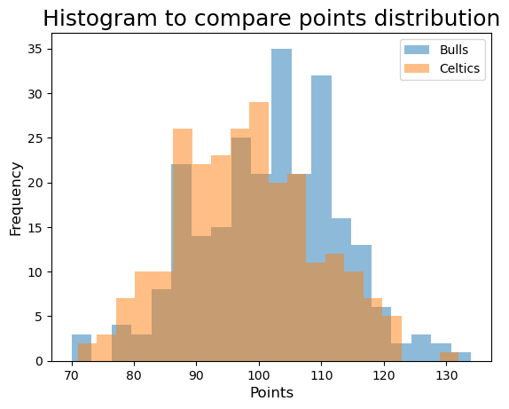

The Celtics distribution from 2013 – 2015 shows tighter clustering around the mean, indicating more consistent scoring. In contrast, the Bulls’ 1996 – 1998 scoring shows greater spread, suggesting more variability in game-to-game performances. This comparison underscores how offensive consistency differs across eras and team compositions.

## Descriptive Statistics: Points Scored By Your Team in Home Games

| **-** | **Value** |
| --- | --- |
| Statistic  *Mean*  *Median*  *Variance*  *Standard Deviation* | 98.82  99.5  107.67  10.38 |

Descriptive statistics provide a summary of how the Boston Celtics performed in home games form 2013 – 2015. Measures of central tendency; such as Mean & Median; indicate the average and middle value of the points scored. Measures of variability; such as Variance & Standard Deviation; indicate the spread or consistency of those values. The mean score of 98.82 suggests that the Celtics typically scored close to 99 points in home games. The median score of 99.50 further confirms that the distribution is relatively symmetrical. The small difference between the mean and median implies a bell-shaped curved; normally distributed pattern with no significant skew. With a variance of 107.67 and a standard deviation of 10.38, this suggests moderate variability in scoring performance. Since the distribution is approximately normal, the mean is an appropriate measure to represent the center of the distribution.

## Descriptive Statistics: Points Scored By Your Team in Away Games

| **Statistic Name** | **Value** |
| --- | --- |
| Statistic   *Mean*  *Median*  *Variance*  *Standard Deviation* | 97.28  96.00  121.43  11.02 |

The Celtics performance in away games from 2013 – 2015 shows slightly more variability then their home games. The mean score of 97.28 and median score of 96 indicate a small discrepancy, suggesting a slight left skew in the distribution. This means that a few lower-than-average scoring games may have pulled the mean below the median. The variance and standard deviation are higher for away games compared to home games, indicating that the Celtics scoring was less consistent on the road against teams. Given this skew, the median may be a better measure of central tendency for away games. By comparison of home and away game performance, it is clear that the Celtics scored more consistently and slightly higher at home games: Mean = 98.82, std dev = 10.38; than in away games: Mean = 97.28, std dev = 11.02. This supports the idea of home court advantage for the Celtics as this contributes to the team’s performance.

## Confidence Intervals for the Average Relative Skill of All Teams in Your Team’s Years

| **Confidence Level (%)** | **Confidence Interval** |
| --- | --- |
| XX% (for example, 95%)  95% | (X.XX, X.XX)  *\*Round off to 2 decimal places.*  (1502.02, 1507.18) |

Confidence are a statistical tool used to estimate population parameters with a degree of certainty. In this case, the 95% confidence interval provides a range in which the average relative skill (ELO) of all NBA teams between 2013 – 2015 is expected to fall. The interval (1502.02, 1507.18) indicates that with 95% confidence the true population mean relative skill for all teams during the given timeline lies within this range of values. This suggests that the league average relative skill was fairly consistent and centered around 1505. If a different confidence level; such as 99%; was chosen, the interval would have been wider; reflecting greater uncertainty. Conversely, if a 90% confidence interval would yield a narrower interval but with less confidence.

The probability that a team has a relative skill less than the Celtics is extremely low; calculated at near 0%. This means that the Celtics had a much lower relative skill than the average team during this period, and it is not unusual for teams to outperform them based on relative skill.

## Confidence Intervals for the Average Relative Skill of All Teams in the Assigned Team’s Years

| **Confidence Level (%)** | **Confidence Interval** |
| --- | --- |
| XX% (for example, 95%)  95% | (X.XX, X.XX)  *\*Round off to 2 decimal places.*  (1487.66, 1493.65) |

The confidence Interval for the average relative skill of all teams for the assigned team’s years; between 1996 – 1998; is (1487.66, 1493.65). This interval reflects the average performance level of all NBA teams during this period. Compared to the confidence from 2013 – 2015, this range is slightly lower, indicating that the average relative skill scores across the league were somewhat reduced in earlier periods of the league. This can be contributed to a multitude of factors such as; changes in competition level, style of gameplay, or team dynamics over time. If a different confidence level had been used, the interpretation remains the same, but the width of the interval would change. For example, a 99% confidence interval would widen to ensure more certainty, while a 90% interval would narrow.

The Bull’s relative skill was much higher than the league average, leading to a very low probability that another random team would exceed their skill level. This highlights their dominance during the late 90s and further emphasizes the performance of the team during the Jordan era.

## Conclusion

This statistical analysis provides a comprehensive comparison between the Boston Celtics (2013 – 2015) and the Chicago Bulls (1996 – 1998) using data visualization, descriptive statistics, and inferential methods. Through histograms, KDE plots, and confidence intervals, each team was evaluated for their scoring behavior and relative performance. The results revealed that the Celtics had average offensive output with moderate consistency; especially for home games. In contrast, the Bulls from the late 90s demonstrated significantly higher relative skill and variability in scoring. The confidence intervals confirmed that league-wide performance was slightly stronger during the 2013 – 2015 seasons, but the Bulls still stood out as the better team during their era. The insights provided are valuable for coaching staff, analysts, and sports managers aiming to assess team performance relative to league norms. They also demonstrate how statistical techniques can offer meaningful interpretations beyond surface level metrics, enabling more informed decision-making processes for Team strategy and evaluation.